Civil war in Georgia

UNSC Resolution: | 1225
Date of adoption: | 28-Jan-1999
Operative paragraph: | 2
Demand number: | 1225.0211

David Siroky

Wording of demand

resume bilateral negotiations after the failure of the Athens meetings of 16-18 October 1998 on confidence building measures, agreements on security and the non-use of force, the return of refugees and displaced persons and economic reconstruction

List of addressees of the demand

Government of Georgia, Abkhazia

Short-term compliance

Description of the addressee(s)’ conduct

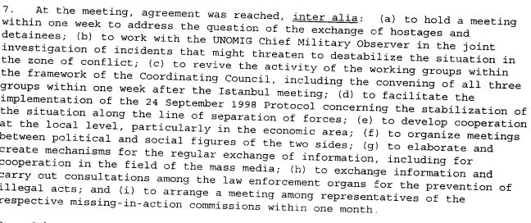s/1999/805

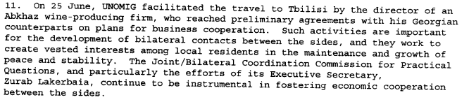
s/1999/805

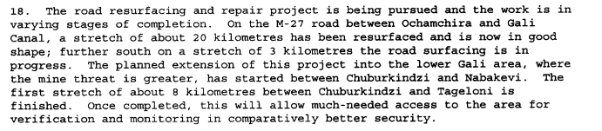
s/1999/805

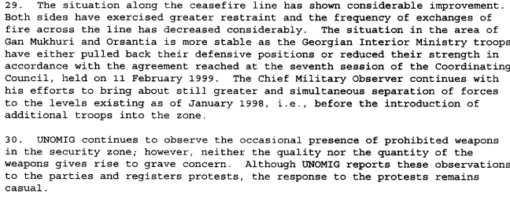
s/1999/805

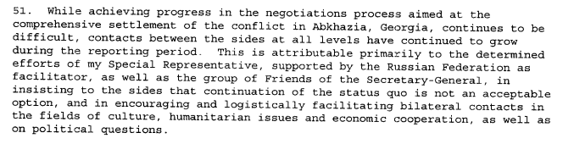
s/1999/805

Assessment

Short-term compliance
No or marginal compliance (1) | Medium low compliance (2) | Medium high x3 compliance (3)

Considerations underlying the assessment

Medium-term compliance

Description of the addressee(s)’ conduct

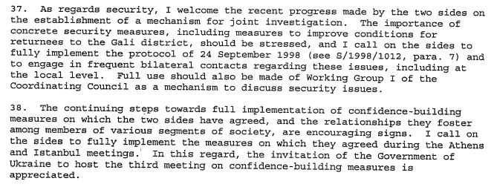s/2000/39

Assessment

Medium-term compliance
No or marginal compliance (1) | Medium low compliance (2) | Medium high x3 compliance (3)

Considerations underlying the assessment

Depth of demand

Assessment

Level of depth of demand
Low depth of demand (1) | Medium depth of demand (2) x2

Considerations underlying the assessment

Level of confidence about coding decisions
Level of confidence about coding decision
Extremely high | High x

Comments to IPI (if any)

Civil war in Georgia

UNSC Resolution: | 1225
Date of adoption: | 28-Jan-1999
Operative paragraph: | 6
Demand number: | 1225.0611

David Siroky

Wording of demand

observe strictly the Moscow Agreement (S/1994/583, annex I) and also the ceasefire protocol signed on 25 May 1998, as well as all their obligations to refrain from the use of force and to resolve disputed issues by peaceful means only in addition to display greater resolve and willingness to make the Joint Investigation Group functional

List of addressees of the demand

Government of Georgia, Abkhazia

Short-term compliance

Description of the addressee(s)’ conduct

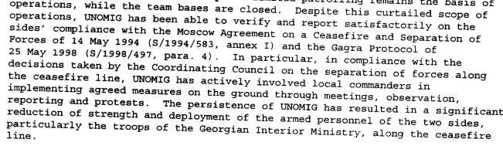
s/1999/805

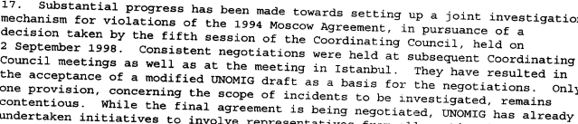
s/1999/805

s/1999/805

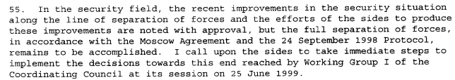
s/1999/805

Assessment

Short-term compliance
No or marginal compliance (1) | Medium low compliance (2) | Medium high x3 compliance (3)

Considerations underlying the assessment

Medium-term compliance

Description of the addressee(s)’ conduct

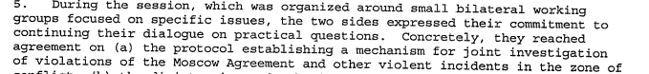s/2000/39

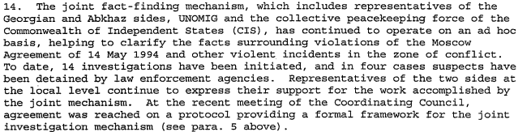s/2000/39

s/2000/39

s/2000/39

Assessment

Medium-term compliance
No or marginal compliance (1) | Medium low compliance (2) | Medium high x3 compliance (3)

Considerations underlying the assessment

Depth of demand

Assessment

Level of depth of demand
Low depth of demand (1) | Medium depth of demand (2) x2

Considerations underlying the assessment

Level of confidence about coding decisions
Level of confidence about coding decision
Extremely high | High x

Comments to IPI (if any)

Civil war in Georgia

UNSC Resolution: | 1225
Date of adoption: | 28-Jan-1999
Operative paragraph: | 7
Demand number: | 1225.0711

David Siroky

Wording of demand

address the situation of refugees and displaced persons, resulting most recently from the hostilities of May 1998, in the context of the Quadripartite Agreement (S/1994/397 Annex II) urgently by agreeing and implementing effective measures to guarantee the security of those who exercise their unconditional right to return

List of addressees of the demand

Government of Georgia, Abkhazia

Short-term compliance

Description of the addressee(s)’ conduct

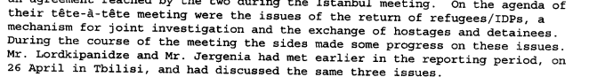
s/1999/805

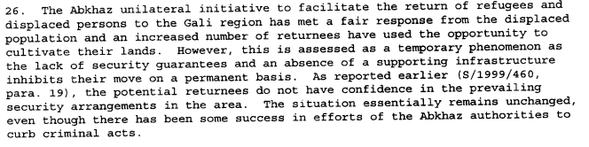s/1999/805

s/1999/805

Assessment

Short-term compliance
No or marginal compliance (1) | Medium low compliance (2) x2 | Medium high compliance (3)

Considerations underlying the assessment

Medium-term compliance

Description of the addressee(s)’ conduct

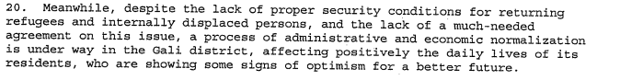
s/2000/39

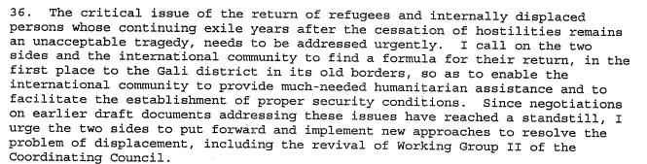
s/2000/39

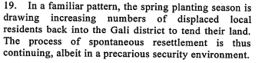
s/2000/345

Assessment

Medium-term compliance
No or marginal compliance (1) | Medium low x2 compliance (2) | Medium high compliance (3)

Considerations underlying the assessment

Depth of demand

Assessment

Level of depth of demand
Low depth of demand (1) | Medium depth of demand (2) x3

Considerations underlying the assessment

Level of confidence about coding decisions
Level of confidence about coding decision
Extremely high | High x

Comments to IPI (if any)

Civil war in Georgia

UNSC Resolution: | 1225
Date of adoption: | 28-Jan-1999
Operative paragraph: | 8
Demand number: | 1225.0811

David Siroky

Wording of demand

resume and intensify bilateral dialogue to facilitate the safe return of refugees and displaced people to the Gali region, as a first step

List of addressees of the demand

Government of Georgia, Abkhazia

Short-term compliance

Description of the addressee(s)’ conduct

s/1999/805

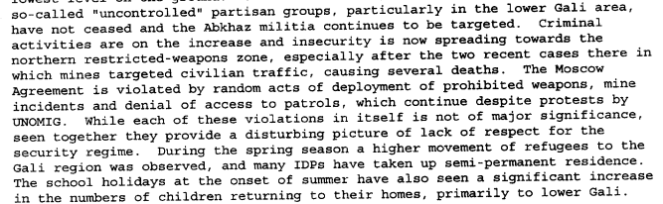s/1999/805

s/1999/805

s/1999/805

Assessment

Short-term compliance
No or marginal compliance (1) | Medium low x2 compliance (2) | Medium high compliance (3)

Considerations underlying the assessment

Medium-term compliance

Description of the addressee(s)’ conduct

s/2000/39

s/2000/39
s/2000/345

Assessment

Medium-term compliance
No or marginal compliance (1) | Medium low x2 compliance (2) | Medium high compliance (3)

Considerations underlying the assessment

Depth of demand

Assessment

Level of depth of demand
Low depth of demand (1) | Medium depth of demand (2) x2

Considerations underlying the assessment

Level of confidence about coding decisions
Level of confidence about coding decision
Extremely high | High x

Comments to IPI (if any)

Civil war in Georgia

UNSC Resolution: | 1225
Date of adoption: | 28-Jan-1999
Operative paragraph: | 10
Demand number: | 1225.1011

David Siroky

Wording of demand

take immediate and determined measures to put a stop to acts, including the continued laying of mines, especially in the Gali region, and ensure that the security environment of all international personnel improves significantly

List of addressees of the demand

Government of Georgia, Abkhazia

Short-term compliance

Description of the addressee(s)’ conduct

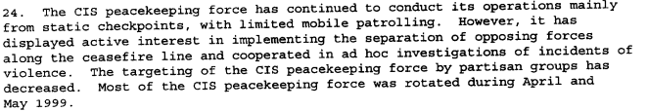
s/1999/805

s/1999/805

s/1999/805

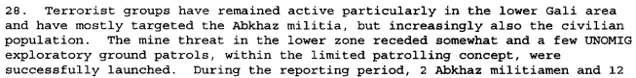
s/1999/805

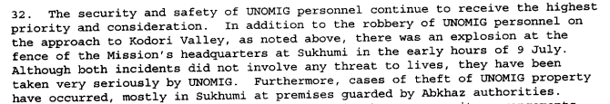s/1999/805

Assessment

Short-term compliance
No or marginal compliance (1) | Medium low compliance (2) x2 | Medium high compliance (3)

Considerations underlying the assessment

Medium-term compliance

Description of the addressee(s)’ conduct

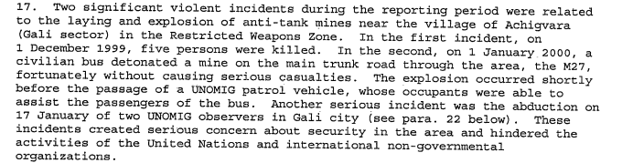
s/2000/39

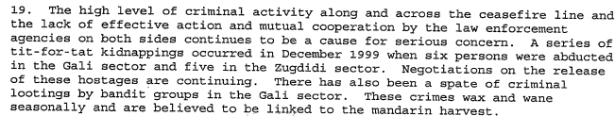s/2000/39
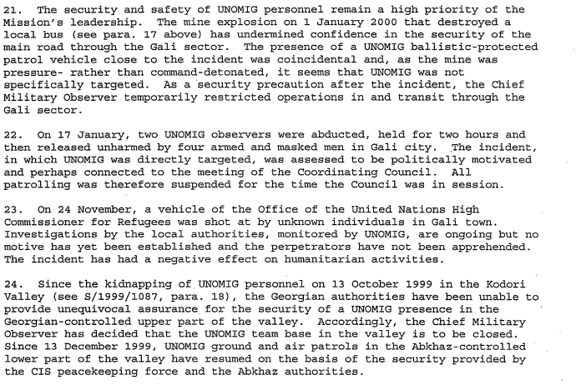
s/2000/39

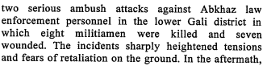
s/2000/345

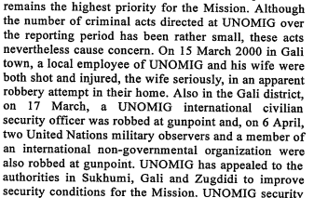
s/2000/345

Assessment

Medium-term compliance
No or marginal compliance (1) x1 | Medium low compliance (2) | Medium high compliance (3)

Considerations underlying the assessment

Depth of demand

Assessment

Level of depth of demand
Low depth of demand (1) | Medium depth of demand (2) x2

Considerations underlying the assessment

Level of confidence about coding decisions
Level of confidence about coding decision
Extremely high | High x

Comments to IPI (if any)

